Full name……………………...  Class 3…… |  |  | THE FIRST TERM TEST  ENGLISH: 3  Time: 40 minutes
 | MARK | COMMENTS

PART I. LISTENING (4 pts)
1. Listen and circle (1pt)
0. Girl: May I __________, Miss Hien?
Miss Hien: No, you can’t.
a. stand up b. come in ©. go out
1. Miss Hien: Good morning class!
Class: Good morning Miss Hien!
Miss Hien: ___________, please!
a. Stand up b. Sit down c. Come in
2. Miss Hien: _________!
Boy: Sorry Miss Hien.
a. Be quiet b. Stand up c. Good morning
3. Class: Goodbye Miss Hien!
Miss Hien: ________ class.
a. don’t talk b. come here c. goodbye
4. Mai: May I _______?
Miss Hien: Yes, you can
a. go out b. come here c. come in

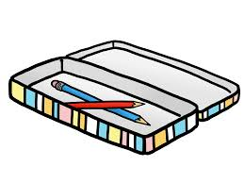
2. Listen and tick (1pt)
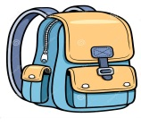
c

b
a
1.
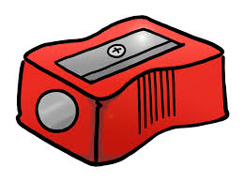

c
b
a
2.
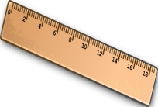
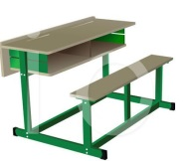

c
b

a
3.
b

c
4.
a

3. Listen and number. (1pt)
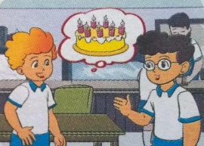
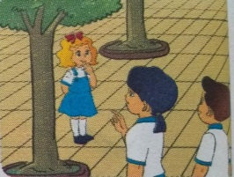
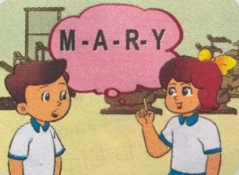
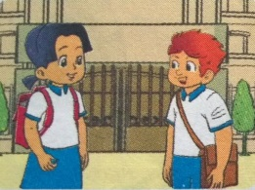

d
c
b
a

4. Listen and complete (1pt)
0. I’m eight years old.
- Is ………your friend?
- These are my ………
- My pen is………
- The school ………..is large.
PART II. READING AND WRITING (4pts)
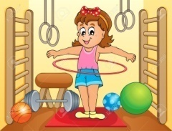 | 1.That is the computer room.
 | 2. May I come in ?
 | 3. This is my pen.
 | 4. This is a pencil case.
5.Look and read. Put a tick ( ) or cross (X ) in the box. (1pt)

6.Look and read. Write Yes or No. (1pt)
 | - football  ______ | 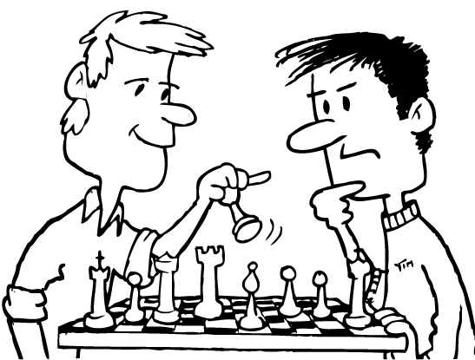 | 2. chess  _____________
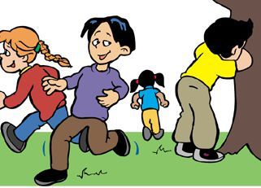 | 3.hide- and- seek.  _______________ |  | 3.basketball  ____________

7.Look at the pictures. Write the words. (1pt)

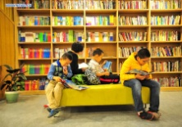 | 1.lrybral → | l ………………..
 | 2.tobfolal → | f ………………..
 | 3.tignaks → | s ………………..
 | 4.bgasoolch → | s………………..

8.Fill in each gap with a suitable word from the box (1 pt)

school things pencils Those school bag

There are some (1)…………………… on my desk. This is my (2) …………... It is yellow. That is my notebook. It’s blue. These are my (3)…….………… They are black. (4)……………. are my rubbers. They are orange. What colour are your rubbers?

PART III. SPEAKING (2pt)

**** The end ****

MA TRẬN ĐỀ KIỂM TRA MÔN TIÊNG ANH LỚP 3
HỌC KỲ 1( 2018-2019)

Kỹ năng đánh giá | Kiến thức cần đánh giá | Mức/ điểm |  |  |  | Tổng số câu , số điểm, tỉ lệ %
 |  | M1 | M2 | M3 | M4
Listening  4pts =40% | 1. Listen and circle |  | 0,5đ  (2 câu) | 0,5đ  (2 câu) |  | 4 câu = 1 điểm
 | 2. Listen and tick | 0,25đ  (1câu) | 0,5đ  (2 câu) | 0,25đ  (1câu) |  | 4 câu = 1 điểm
 | 3. Listen and number | 1đ  (4 câu) |  |  |  | 4 câu = 1 điểm
 | 4. Listen and complete | 0,5đ  (2 câu) |  | 0,25đ  (1 câu) | 0,25đ  (1 câu) | 4 câu = 1 điểm
Reading  2pts = 20% | 5. Read and tick (v) or (x) |  | 0, 5đ  (2 câu) | 0,25đ  (1 câu) | 0,25đ  (1 câu) | 4 câu = 1 điểm
 | 6. Read and write Yes/No |  | 0,5đ  (2 câu) | 0,25đ  (1 câu) | 0,25đ  (1 câu) | 4 câu = 1 điểm
Writing  2pts = 20% | 7. Look and write the words in order. |  | 0,5đ  (2 câu) | 0,5đ  (2 câu) |  | 4 câu = 1 điểm
 | 8. Fill in the gaps |  |  | 0,5đ  (2 câu) | 0,5đ  (2 câu) | 4 câu = 1 điểm
Speaking  2pts = 20% | -Respond the questions of teacher. | 1đ  (4 câu) |  |  |  | 8 câu= 2 điểm
 | -Discribe the pictures in sts’ book by answering questions of teacher. | 0,5đ  (2 câu) | 0,5đ  (2 câu)
Tổng số câu |  | 13 câu | 12 câu | 10 câu | 5 câu | 40 câu

Answer Key:

Q | Answer | point | total
1 | 1-b 2-a 3-c 4-c | 0,25/ each | 1 pt
2 | 1- b 2- a 3- b 4-c | 0,25/ each | 1 pt
3 | 1-c 2-d 3-a 4-b | 0,25/ each | 1 pt
4 | 1. that 2. Books 3. Blue 4. Playground | 0,25/ each | 1 pt
5 | 1. X 2.V 3. V 4. x | 0,25/ each | 1 pt
6 | 1. No 2. Yes 3. No 4. No | 0,25/ each | 1 pt
7 | 1. library 2. football 3. skating 4. school bag | 0,25/ each | 1 pt
8 | 1. school things 2. School bag 3. pencils 4. Those | 0,25/ each | 1 pt
9,10 | Speaking test | 0,25/ each | 2 pts

